Networks, Internet, & Digital Citizenship Packet
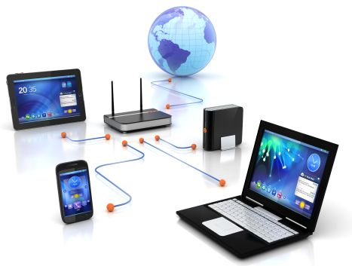

Computer Technology

Name: __________________________________
Network Definition: a series of points or nodes interconnected by communication paths.
Network Vocabulary

Draw an example of a network.

List the different types of networks and the type of data they transmit.

Define:

- Client:

- Server:

- Firewall:

- Network speed:

- Gateways:

- PSN:

- DNS:

- IP Address:

- WAN:

- LAN:

- VPN:

Describe possible security issues while using a network and the role of a firewall.

List a few troubleshooting options when your computer fails to connect to a network.

Internet
.

Define
- Internet

- Browser
  - List a few examples of web browsers.
- Domain

- Hyperlink

- Plugins
List the steps to create a bookmark or favorite in a browser.

List the steps to view the browser history.

List the steps to set the homepage of a browser.

Describe the difference between download and upload.

Internet Collaboration Assignment:
Students will split into groups of two to four for this assignment. Student must log into their Google Drive Account. Each group will assign a group leader to create and share a Google Spreadsheet, naming it Automobiles. The spreadsheet must also be shared with the teacher.
Select cells A1:G1 and merge. Enter the title Automobile Ranking Review.
Insert the following headings in row 3.

Student Name | Category Bodystyle | Year | Rank | Make | Model | Low MSRP Price | City MPG | Hwy MPG | Overall Ranking

Using the site usnews.rankingsandreviews.com, each student must contribute five automobiles to the spreadsheet. You cannot do the same automobile as someone else.

Internet Searches

Perform an advanced internet search. Search for a picture of a mountain. Filter for large images only those labeled for reuse.

Describe signs to determine the validity of a website.

Define:
- Creative commons

- All rights reserved
Digital Citizenship

List uses of the internet.

With more technology becoming integrated in both our personal and professional lives, we have access to great tools. Complete an internet search on the negative impact that technology has on society. Report your finding below.

Describe our social responsibility when using the internet.

Define
- Spam:
- Flaming:
- Cyber-bullying:
- Libel:
- Slander:
- Censorship/Filtering:
- Piracy:

List three examples of intellectual property that may be copyrighted.

Describe copyright. How do you obtain a copyright?

