Go to http://www.howtogeek.com/howto/15677/zen-and-the-art-of-file-and-folder-organization/ and read until you get to the heading labeled: Tips of Getting Organized.

Are you finished reading? Good. The author assumed that you knew what a file was and how to create, save, and delete them. We’re not going to assume so much. Each time you type up an essay in English class and save it, you’ve created a new Microsoft Word file. Now we’ll begin trying a few tips to begin the art of file organization.
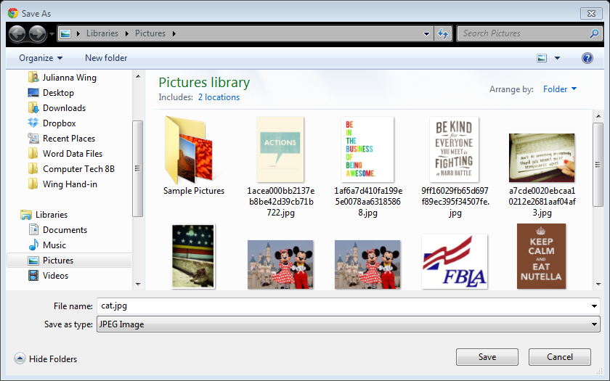
When you find a picture of a cat from a Google search and click “save as”, you’re creating a new file. Let’s try it. Go find a picture of a cat in 30 seconds or less. Click to view the full image. Right click on the image and choose to “Save picture as”. Change the picture name to cat but leave the file extension (.jpg or .png, etc.)
Save a cat picture.
Tip #7. Name Files and Folders Intelligently
There are a few places that are important to know. From the desktop, open the folder labeled Business. Inside, find the folder labeled Microsoft Office Pro 32-bit. Open it up to find Microsoft Word, Excel, etc. Memorize this pathway.
Open up a Microsoft Word document. Type “Hello World” in the body. Add the cat picture if you know how. If not, don’t worry because we’ll go over that later.
In order to make our files easy to find, we’re going to name them properly. (Mr. Cox’s secret mission is not a good file name). For Computer Tech, please label all assigned class work accordingly:
Class period-last namefirst name-assignment name
Example: 8-wingjulianna-file organization
Save your file the correct way.
Save vs. Save As
Saving a file is how you update the last change made to the file. Make sure to save OFTEN while working in class! Save As gives you the chance to save a file with a different name or in a different location.
Open the file organization assignment and from the File Tab, select Save As and change the name to Hello World.
Perform a Save As.
Tip #3. Choose the Root Folder of Your Structure Carefully
ALL DOCUMENTS will be saved in your student drive. This way you have access to them anywhere in the school. DO NOT save onto the individual computer. If you switch computers, you’re files will not be there!
From the Windows Menu, click on Computer, find your student drive.
Identify your student drive.
Tip #4. Use Sub-Folders
Time to create folders. Open your student drive and create a new folder labeled Computer Technology. To create a new folder, right click and choose new folder or click on the new folder option.
Create the following folders inside of your Computer Tech folder.
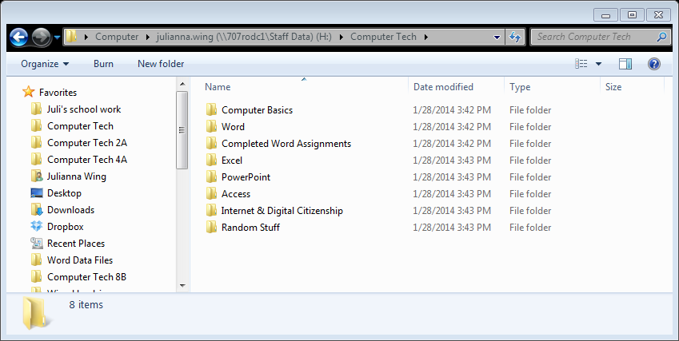
- Computer Basics
- Word
- Completed MOAC Assignments
- Excel
- PowerPoint
- Access
- Internet & Digital Citizenship
- Random Stuff
Feel free to create folders for your other classes to separate your files.
Pass off file organization.
Rearranging our folders
- Move the “Completed MOAC Assignments” folder inside of the Word folder by simply clicking and dragging.
- Select the folder labeled “Random Stuff” and press the Ctrl and C keys to copy the folder. Press Ctrl and V to paste to create a duplicate folder.
- Right click on the folder labeled “Random Stuff” and choose rename. Change the name to Misc.
- Delete the first folder labeled “Random Stuff”.
Move, copy, rename, & delete a folder.
Finding Files
Here’s another place to remember. Go back to the Business folder. Click on the Student Common Folder.
Click on Wing, then Computer Tech. Here is where you can find files, not uploaded to my website.
Now, using the search bar in the top, right look for a file named My Movie.
Search for a file.
Mac vs. PC
If you are in the Mac lab, you can still access your files using a little puzzle piece called Finder.
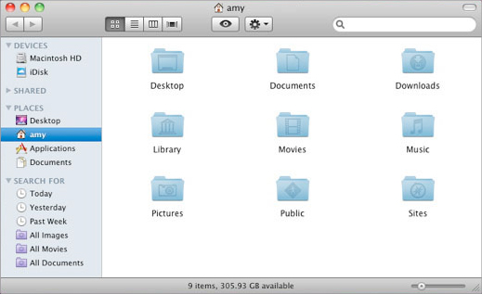
Use shortcuts
Shortcuts can save a lot of time when using different programs. Here are a few shortcuts to remember. Try a few of them out.
Alt + Tab | Cmd +Tab | Switches windows, | Ctrl + S | Cmd + S | Save
Ctrl + O | Cmd + O | Open | Shift + Ctrl + S | Shift + Cmd +S | Save As
Ctrl + P | Cmd + P | Print | Ctrl + A | Cmd + A | Select All
Ctrl + C | Cmd + C | Copy | Ctrl + “+” | Cmd + “+” | Zoom In
Ctrl + X | Cmd + X | Cut | Ctrl + “-“ | Cmd + “-“ | Zoom Out
Ctrl + Z | Cmd + Z | Undo | Ctrl + N | Cmd + N | New Document
Ctrl + Y | Cmd + Y | Redo | Ctrl + F | Cmd + F | Find
Show off some shortcuts.

