Name:
Label the parts of an Access 2010 window.
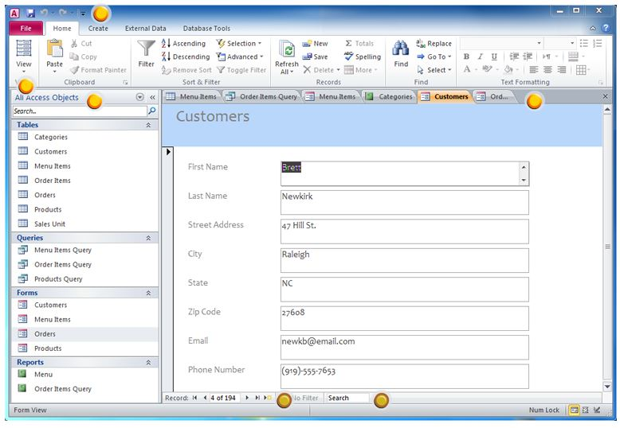

This part of Access contains all of the objects contained in your database. _________________

Draw a picture of what button you would push to go to a next record in your database.

Match the terms with their definitions.

_____ 1. Field | a. A collection of records
_____ 2. Record | b. Categories for records
_____ 3. Query | c. Finding certain records that meet a need
_____ 4. Table | d. Information for a particular file

Quizzes (Must score above 80%)
Module 1 Quiz Scores:

Module 2 Quiz Scores:

List one example of when Access could be used:

